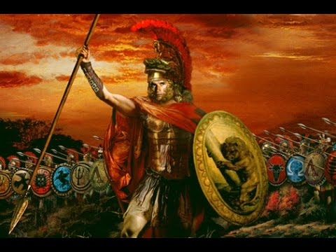
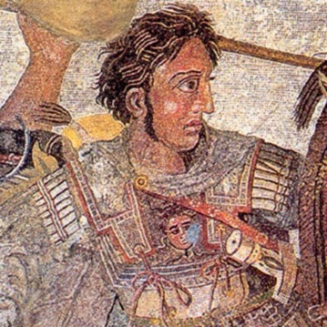

Alexander the Great: Campaign Poster
Use sections 30.4 – 30.8
Your goal: Convince people to join Alexander’s empire!
Must include:
- Main “catchy” slogan
- Options for a visual
  - Drawing of Alexander
  - Drawing of his Empire (map)
  - Your own idea
- At least 3 reasons why it makes sense for people to join Alexander’s empire

